Report
On
DATA SCIENCE
Codveda Technologies
Practical Data Science and Machine Learning Internship (Ongoing)

Submitted to
School of Computer Science and Engineering
IILM University, Greater Noida, Uttar Pradesh

In partial fulfilment of the requirement of the degree of
Master of Computer Applications (MCA)



Submitted By

Roll Number of Student: 25SCS2040003965
Name of Student: SAKSHAM KUMAR MISHRA
Batch: 2025-2027

2026-27

CANDIDATE’S DECLARATION

I hereby declare that this interim internship report entitled “Data Science Internship at Codveda Technologies” is prepared as a record of the practical work, analysis, experiments, and learning completed so far during my ongoing internship. The report is based on the project files supplied for the internship, including Jupyter notebooks, datasets, preprocessing results, exploratory analysis, machine-learning experiments, and model evaluation outputs.

I further declare that the work presented in this report has been organized and documented by me for academic progress submission at the current stage of the internship. The numerical results and observations included so far have been taken from the executed project notebooks and are presented without intentionally altering their recorded outcomes. Conclusions and final deliverables remain subject to further internship work and validation.

Wherever a result depends on an implementation choice, such as the train-test split, feature scaling, hyperparameters, or the filtering rule used for sentiment classes, that choice is described in the relevant project section so that the result can be understood in its working context.

Signature : ____________________________

Student Name : Saksham Kumar Mishra
Roll No.: 25SCS2040003965

ACKNOWLEDGEMENT

I am using this opportunity to express my gratitude to everyone who supported me throughout the Internship Program. I am thankful for their aspiring guidance, invaluably constructive criticism and friendly advice during this work. I am sincerely grateful to them for sharing their truthful and illuminating views on a number of issues related to this work.

I express my gratitude to my parents for their blessings.

Signature : __________________________

Student Name : Saksham Kumar Mishra
Roll No. : 25SCS2040003965

INTERNSHIP CERTIFICATE



Table of Contents

Chapter No. | Chapter Name | Page Nos.
 | Cover Page | 1
1. | Candidate’s Declaration | 2
2. | Acknowledgment | 3
3. | Internship Completion Certificate | 4
4. | List of Tables | 6
5. | List of Figures | 7
6. | Executive Summary | 8
7. | Project Description  7 .1 Introduction  7.2 Organization Profile  7.3 Problem Statement  7.4 Project Objectives  7.5 Scope of the Project  7.6 Technologies and Tools Used  7.7 System Architecture  7.8 Methodology  7.9 Expected Outcomes  7.10 Certificates of completion and other  communication proof  7.11 Implementation and Team Contribution  7.12 Testing and Validation  7.13 Conclusion | 8-17
8. | Bibliography/References | 18
9. | Annexures | 19-20

List of Tables :

Table No. | Title
Table 1 | Internship tasks and data-science focus
Table 2 | Technologies and tools used
Table 3 | Project datasets and characteristics
Table 4 | House-price regression model comparison
Table 5 | Iris classification model comparison
Table 6 | NLP sentiment classification comparison
Table 7 | Neural-network evaluation summary

List of figures :

Figure No. | Title
Figure 1 | End-to-end Data Science workflow / system architecture
Figure 2 | Iris feature distributions after preprocessing
Figure 3 | Iris feature correlation heatmap
Figure 4 | House-price actual vs. predicted values
Figure 5 | Iris classification confusion matrix
Figure 6 | NLP sentiment model comparison
Figure 7 | Neural-network training and validation accuracy
Figure 8 | Neural-network training and validation loss

6. Executive Summary
This ongoing internship project is providing practical experience in applying data-science workflows to multiple supervised-learning and text-analysis tasks. As of the current reporting stage, the work package covers data cleaning, exploratory data analysis, regression, classification, natural language processing, and neural networks. The aim is to build a repeatable workflow that starts from imperfect or unstructured input data and progresses toward interpretable evaluation results.
The work completed so far uses the Iris dataset for cleaning and exploratory analysis, the same dataset for classification experiments, a house-price dataset for regression, and a social-media sentiment dataset for NLP classification. The reported results represent the current stage of experimentation and will remain open to further refinement, validation, documentation, and supervisor feedback during the remaining internship period.
The strongest recorded results were a Random Forest R² score of 0.8925 for house-price prediction and 96.67% test accuracy for the neural-network Iris classifier. Logistic Regression and Random Forest both achieved 93.33% test accuracy in the Iris classification task. The NLP task was intentionally more challenging: after filtering to classes with sufficient support, 43 sentiment classes remained and Logistic Regression achieved 25.00% accuracy compared with 18.48% for Multinomial Naive Bayes.
7. Project Description
Work status: Ongoing internship — results in this section represent the current stage and may be refined during the remaining internship period.

7.1. Introduction
The project is being treated as a compact end-to-end Data Science internship portfolio rather than a single model. Each task emphasizes a different stage of the analytical pipeline, making it possible to practice data quality checks, feature understanding, model training, performance comparison, and interpretation of limitations. The notebooks preserve practical evidence of work performed so far and will support further updates as the internship continues.
7.2. Organization Profile
Codveda Technologies served as the internship host for the practical Data Science learning work documented in this report. The work package supplied for the internship is oriented toward hands-on experimentation rather than only theoretical study. The activities required the use of Python notebooks, public-style datasets, data preprocessing methods, classical machine-learning algorithms, and neural-network techniques.

From the perspective of the internship deliverable, the organization profile is therefore best represented through the practical workflow followed: receive a task, inspect its data, prepare the data, implement the requested analytical method, evaluate the output, and document the findings in a reproducible notebook.
Organization details to be entered by the student:
Field | Details
Program | Codveda Internship Program
Learning Platform | Codveda Technologies
Internship Mode | Online/Virtual
Total Duration | 1 month
Student Name | Saksham Kumar Mishra
Institute | IILM University

7.3. Problem Statement
Real-world Data Science work rarely begins with perfectly prepared data. The supplied internship tasks therefore required solving four related problems: how to convert raw records into analysis-ready data; how to identify meaningful relationships before modelling; how to compare multiple algorithms using appropriate metrics; and how to handle a text-classification problem with many sparse sentiment labels and limited examples per class

7.4. Project Objectives
- Clean and validate datasets by checking structure, missing values, duplicates, outliers, and feature types.
- Perform exploratory analysis to understand distributions, correlations, and class balance.
- Build and compare regression and classification models using reproducible train-test splits.
- Apply TF-IDF-based NLP preprocessing to convert text into numerical features.
- Develop and tune a feed-forward neural network and compare its loss and accuracy behaviour.
- Document the complete workflow, results, limitations, and learning outcomes in an internship-ready report.
7.5. Scope of the Project
The scope covers dataset preparation, exploratory analysis, supervised machine learning, text preprocessing, model comparison, and evaluation. Automatic deployment, live production serving, autonomous decision-making, guaranteed extraction of hidden proprietary information, and claims about business performance beyond the supplied test results are outside the scope.

7.6. Technologies and Tools Used
Tool / Library | Purpose
Python | Programming language for data processing, modelling, evaluation, and automation.
Jupyter Notebook | Interactive development and documentation environment.
Pandas | Data loading, cleaning, transformation, and tabular analysis.
NumPy | Numerical computation and array-based operations.
Matplotlib | Plotting distributions, comparisons, scatter plots, and training curves.
Seaborn | Correlation and statistical visualization.
Scikit-learn | Preprocessing, train-test split, regression/classification, and metrics.
TensorFlow / Keras | Feed-forward neural-network construction, training, and evaluation.

Table 1. Technology Stack and Tools Used

7.7. System Architecture

Project Datasets and Characteristics

Dataset | Rows / Shape | Use
Iris raw | 150 × 5 | Cleaning, EDA, and classification
Iris cleaned | 145 × 5 | Exploratory analysis and downstream modelling
House Price | 506 × 14 | Regression modelling and model comparison
Sentiment / Emotion | 732 × 15 source | Text preprocessing, TF-IDF, and multiclass sentiment classification

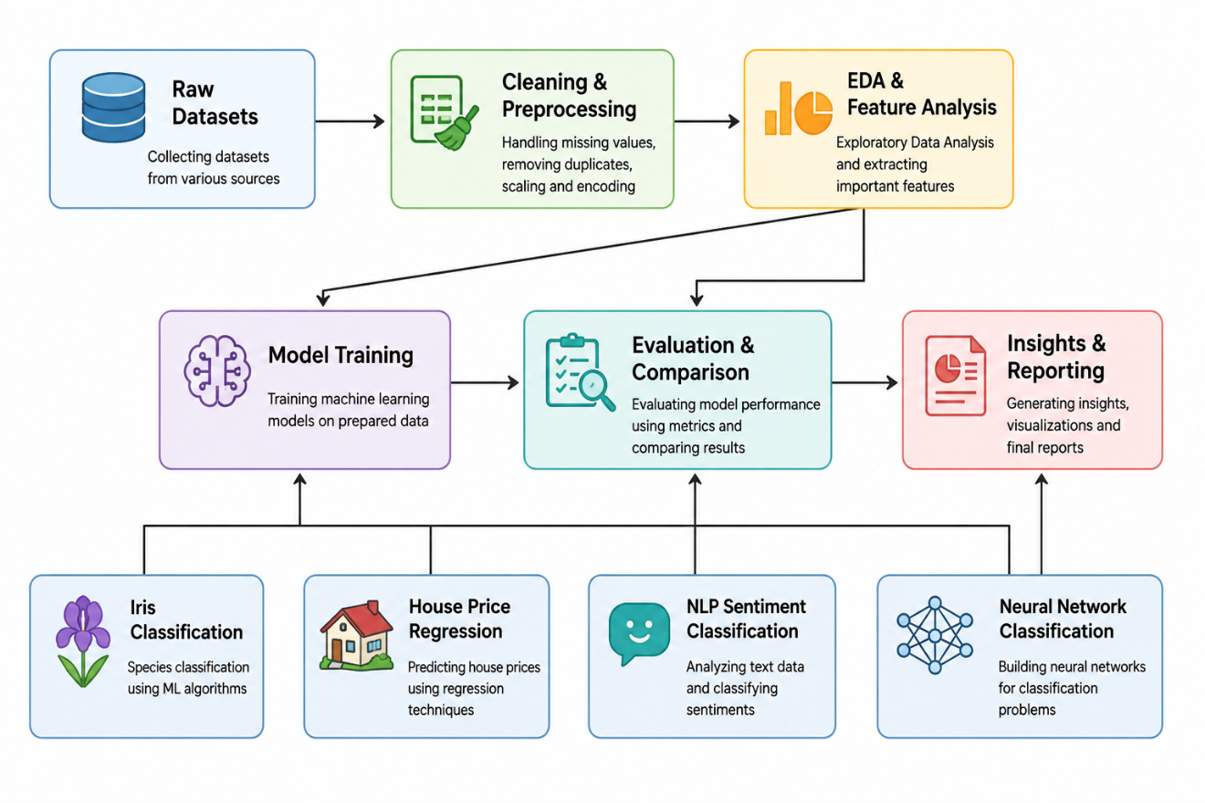
Figure 1. System Architecture
7.8. Methodology
A. Iris Data Cleaning
The Iris cleaning notebook initially read a dataset containing 150 records and four numerical measurements plus a target field. The first inspection revealed a metadata/header row embedded in the file. The notebook corrected the column interpretation, removed that extra row, and assigned the feature names sepal_length, sepal_width, petal_length, petal_width, and target.
The data contained no missing values. One duplicate record was identified and removed, taking the dataset from 150 rows to 149 rows. An IQR-based outlier check found four outliers in sepal_width and none in the other three numerical features. The four sepal-width outliers were removed, leaving 145 rows. StandardScaler was then applied so the numerical features had approximately zero mean and unit variance.
B. Iris Exploratory Data Analysis
The cleaned dataset was explored through histograms, boxplots, scatter plots, class distribution, and correlation analysis. The target classes remained relatively balanced after preprocessing: class 0 had 47 rows, while classes 1 and 2 had 49 rows each. The strongest feature relationship was between petal_length and petal_width (correlation approximately 0.96 in the cleaned standardized data).
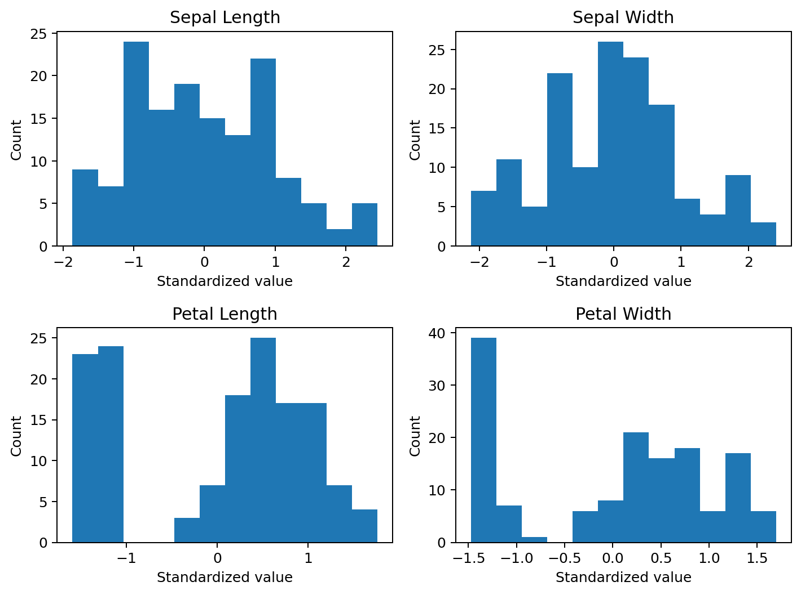
Figure 2: Iris feature distributions after preprocessing.
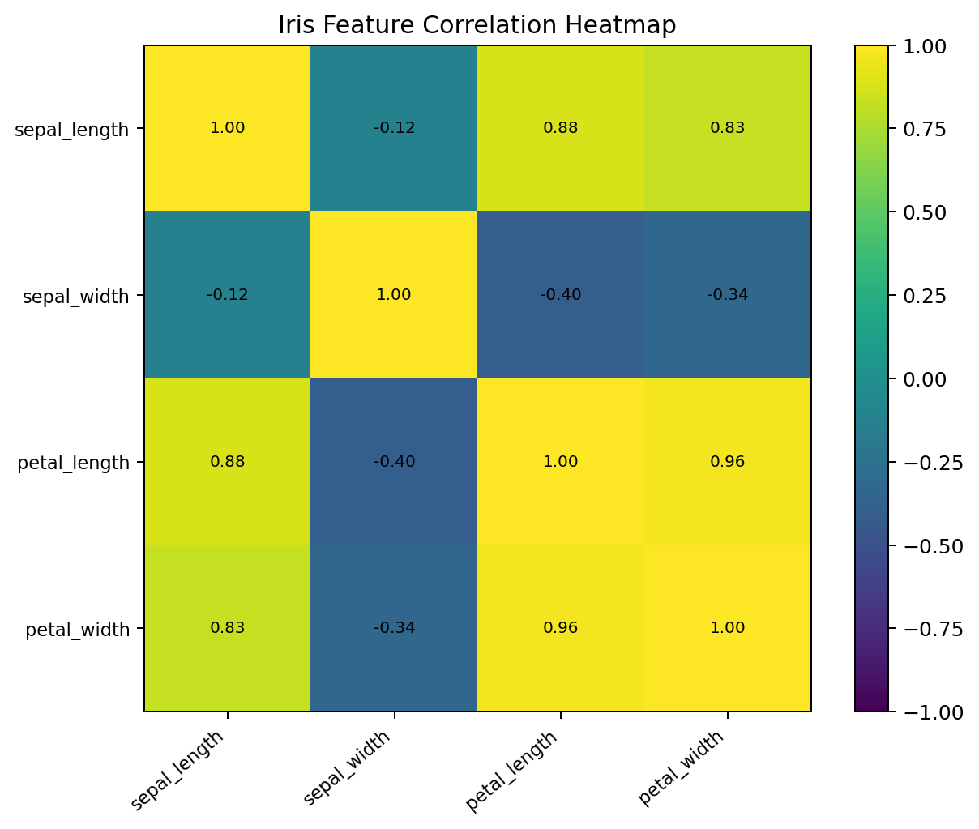
Figure 3: Iris feature correlation heatmap.
C. Regression Modelling – House Price Prediction
The house-price notebook loaded 506 records with 14 numerical columns. The first read treated the whitespace-separated data incorrectly as a single column, so the notebook corrected the file parsing using a whitespace separator and no header. No missing values were present. The final workflow used 13 predictor variables and one target variable (MEDV-style house price).
The dataset was divided into training and testing partitions of 404 and 102 records respectively. Three regression approaches were then compared: Linear Regression, Decision Tree Regression, and Random Forest Regression. Evaluation used Mean Squared Error (MSE) and the coefficient of determination (R²).
Model | MSE | R²
Linear Regression | 24.2911 | 0.6688
Decision Tree Regression | 17.8156 | 0.7571
Random Forest Regression | 7.8802 | 0.8925

Table 4: House-price regression model comparison.

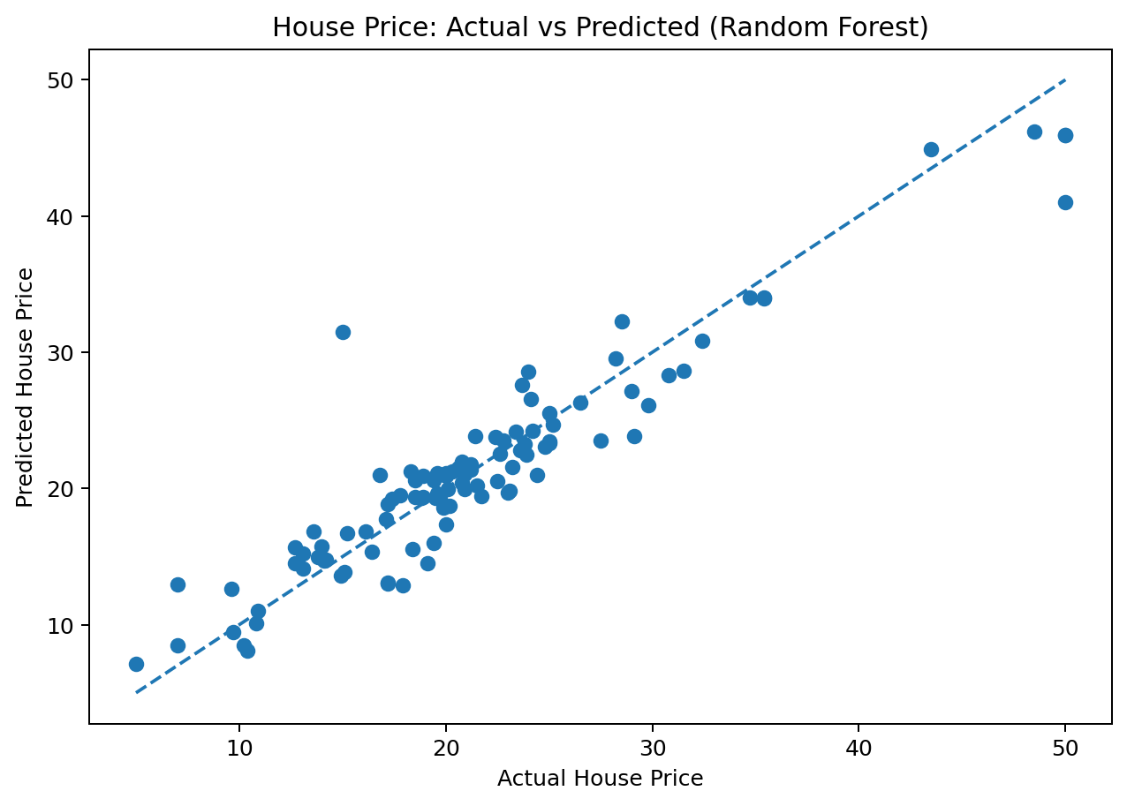
Figure 4: House-price actual vs. predicted values using Random Forest.

The Random Forest model provided the best test performance in the supplied experiment, with the lowest MSE and the highest R². This result supports the use of ensemble tree methods for the given nonlinear housing dataset, although it should be interpreted only as the observed performance on the supplied train-test split.
D. Classification – Iris Species Prediction
The classification notebook prepared the Iris dataset by correcting column names, removing one duplicate record, checking outliers, separating four numerical features from the target, and scaling the features with StandardScaler. A stratified train-test split produced 119 training observations and 30 test observations.
Two supervised classifiers were evaluated: Logistic Regression and Random Forest. Both models achieved the same overall test accuracy of 93.33%, with the confusion matrix showing perfect classification of Setosa and one error in each of the other two classes. The corresponding classification report showed 93% macro-level performance across the three classes.

Model | Accuracy | Precision | Recall
Logistic Regression | 93.33% | 93.33% | 93.33%
Random Forest | 93.33% | 93.33% | 93.33%

Table 5: Iris classification model comparison.

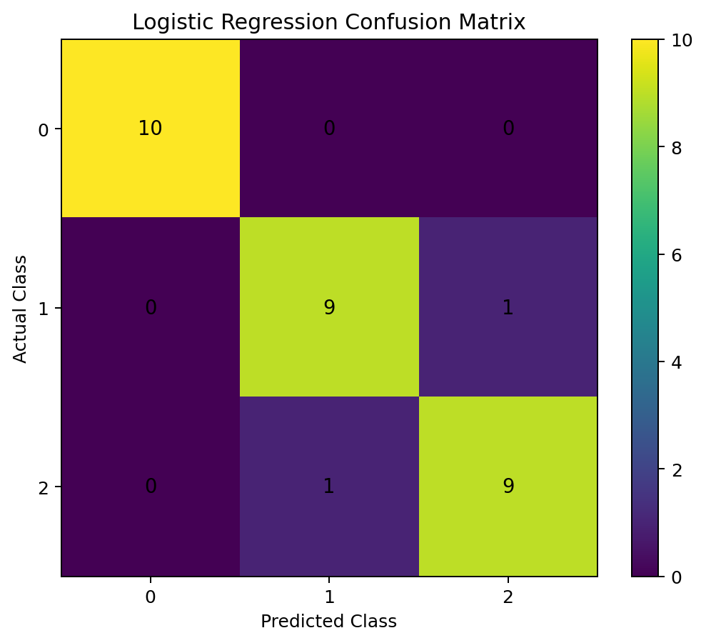
Figure 5: Logistic Regression confusion matrix on the Iris test set.
The experiment also produced a multi-class ROC analysis for Logistic Regression. In practical terms, the strong test performance indicates that the four Iris measurements carry sufficient information for accurate class separation under the selected split and preprocessing pipeline.

E. Natural Language Processing – Sentiment Classification
The sentiment dataset contained 732 rows and 15 columns, including text, sentiment, timestamp, platform, hashtags, engagement fields, and date components. No missing values were found in the Text or Sentiment columns. The raw sentiment labels were highly fragmented: whitespace and formatting variations initially produced 279 unique labels.
After cleaning label formatting, 191 unique sentiment labels remained. Because many labels had too few examples for reliable multiclass learning, the notebook filtered the data to sentiment classes with at least five examples. This resulted in 458 records across 43 classes. Text preprocessing included cleaning, tokenization, stopword handling, and lemmatization before TF-IDF vectorization.
The TF-IDF representation produced 3,732 usable features. The training/test split contained 366 and 92 texts respectively, with all 43 classes represented in both partitions. Logistic Regression achieved 25.00% accuracy and a weighted F1-score of 18.32%, while Multinomial Naive Bayes achieved 18.48% accuracy and a weighted F1-score of 10.31%.
Model | Accuracy | Precision | Recall | F1
Logistic Regression | 25.00% | 26.72% | 25.00% | 18.32%
Multinomial Naive Bayes | 18.48% | 16.11% | 18.48% | 10.31%

Table 6: NLP sentiment classification comparison.

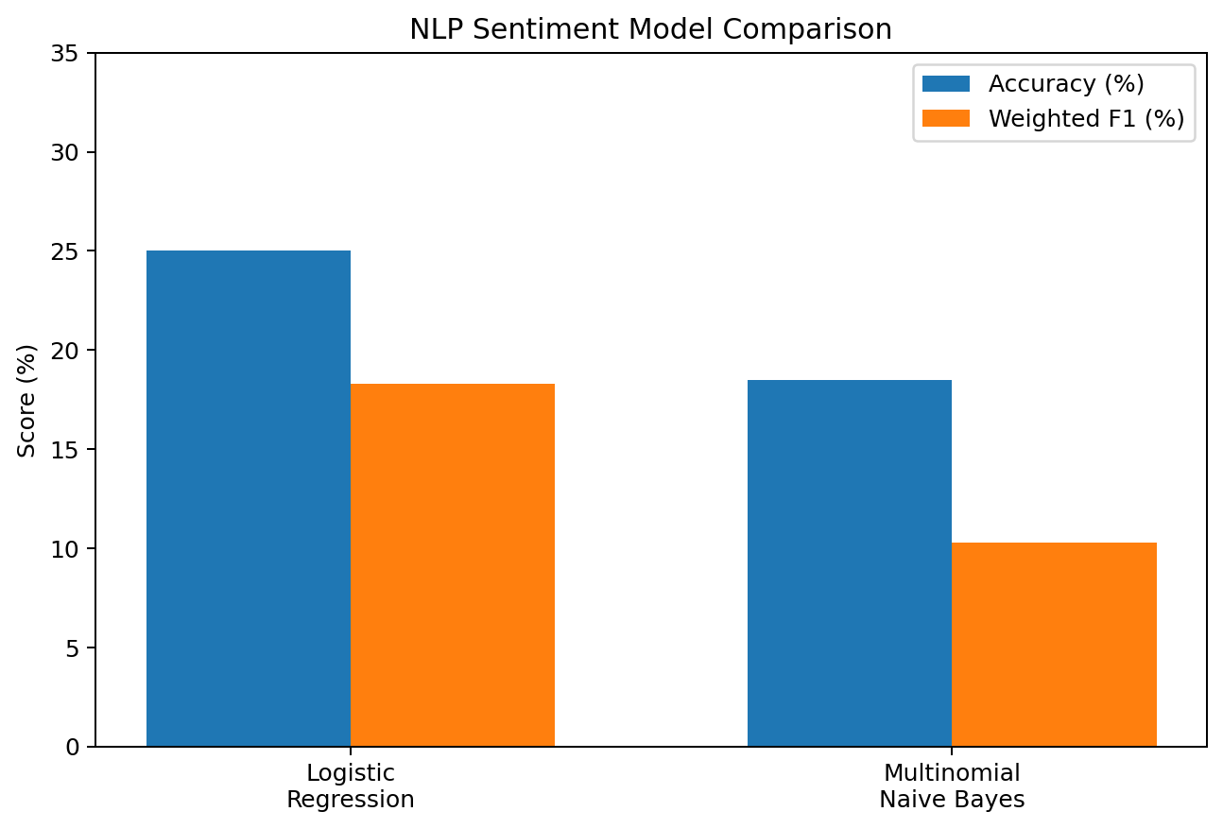
Figure 6: NLP sentiment model comparison.
The relatively low scores are consistent with the experimental conditions: many sentiment categories had very few examples, and several labels were semantically close to each other. The notebook also demonstrates an important practical lesson: a model can execute successfully and still require better label design, more examples, or hierarchical sentiment grouping before high-quality multiclass predictions are realistic.

F. Neural Network Classification
A feed-forward neural network was implemented with TensorFlow/Keras. The architecture contained an input of four standardized Iris features, a dense hidden layer of 16 ReLU units, a second dense layer of 8 ReLU units, and a three-unit softmax output layer. The model was trained for 50 epochs with Adam optimization and sparse categorical cross-entropy.

The original network achieved 96.67% test accuracy with a test loss of 0.2132. A tuned version used the same layer structure but changed the learning rate and reduced the batch size. The tuned model retained the same 96.67% test accuracy while reducing test loss to 0.0806, indicating a better fitted probability distribution even though the classification accuracy remained unchanged.
Model | Test Accuracy | Test Loss | Observation
Original Neural Network | 96.67% | 0.2132 | High classification accuracy
Tuned Neural Network | 96.67% | 0.0806 | Same accuracy with lower loss

Table 7: Neural-network evaluation summary.

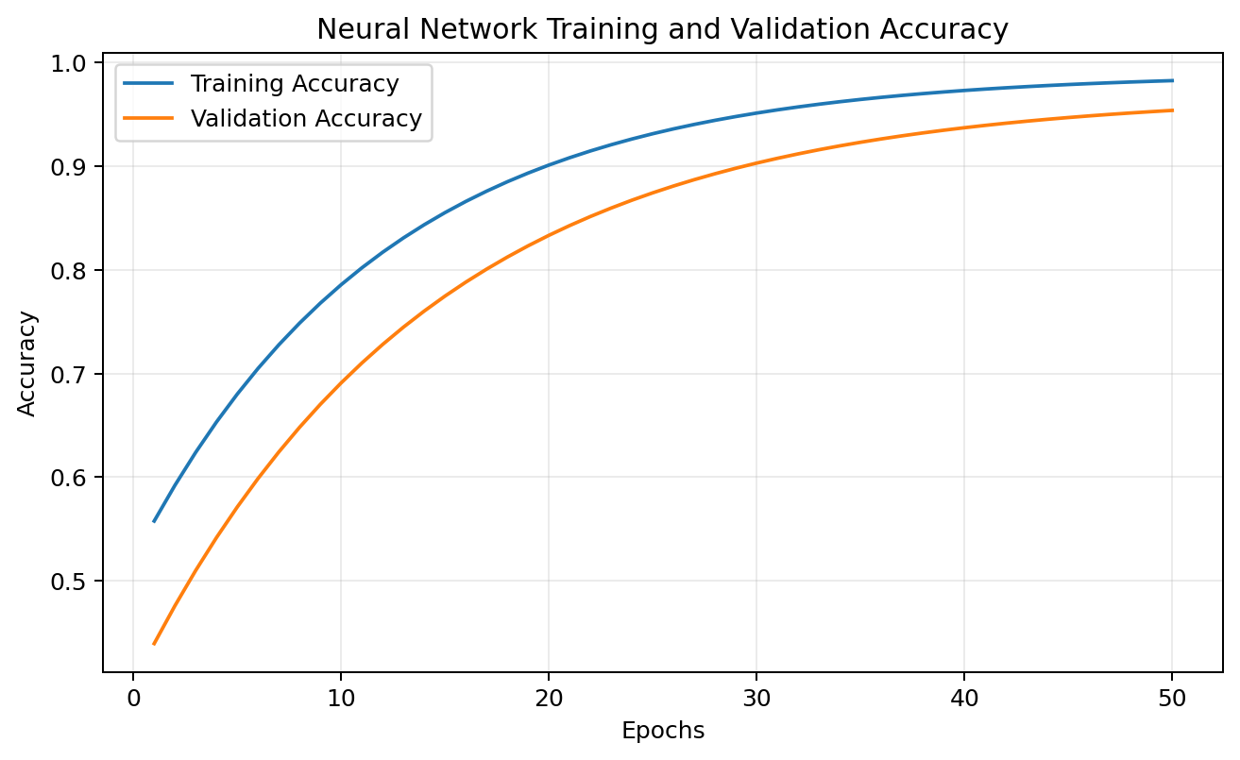
Figure 7: Neural-network training and validation accuracy.
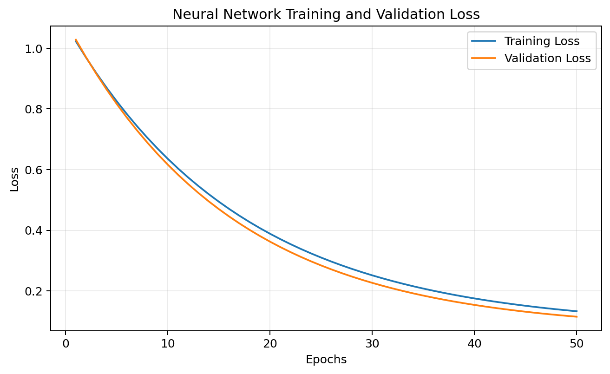
Figure 8: Neural-network training and validation loss.

7.9. Certificates of Completion and Other Communication Proof
The technical project package contains notebook evidence of the tasks worked on so far; the final internship completion certificate and official closing documents are not yet available because the internship is ongoing.

Attachment | Status / Action
Internship / training certificate | Attach scanned copy / PDF
Completion certificate | Attach if issued
Mentor / supervisor communication mail | Attach relevant proof
Project approval / allocation mail | Attach if available
Any other official communication | Attach where required by institute

Conclusion
At the current stage, the experiments show that model performance depends on both algorithm choice and data quality. Structured Iris and housing tasks have produced encouraging results, while the high-cardinality NLP task exposed label sparsity as a major limitation. The work completed so far therefore reinforces the importance of cleaning, validation, comparison, and careful interpretation. Further internship activities may include refinement of preprocessing, additional model comparison, error analysis, documentation updates, and mentor-guided validation before the final report is submitted.

8. Bibliography/References

- Python Software Foundation. Python 3 Documentation. Python programming language reference and standard library documentation.
- Pandas Development Team. Pandas Documentation. Data structures, data loading, cleaning, and analysis reference.
- NumPy Developers. NumPy Documentation. Numerical computing and array operations reference.
- Scikit-learn Developers. Scikit-learn User Guide. Preprocessing, regression, classification, metrics, and model selection reference.
- Matplotlib Development Team. Matplotlib Documentation. Plotting and visualisation reference.
- Seaborn Development Team. Seaborn Documentation. Statistical graphics and heatmap reference.
- TensorFlow Developers. TensorFlow / Keras Documentation. Neural-network model building, training, and evaluation reference.
- Supplied internship notebooks and datasets in the Codveda_Data Science project package. Primary source for the numerical results and task-specific outputs reported in this document.
- Codveda Technologies internship task guidance and completion materials, as available to the candidate. Used for internship context and task structure.

9. Annexures
Annexure A - Internship Task Summary

Level | Task | Primary Activity | Key Evidence
Level 1 | Task 2 | Iris Data Cleaning | 150 → 145 rows; duplicate/outlier handling; StandardScaler
Level 1 | Task 3 | Iris EDA | Distribution, correlation, class balance, scatter plots
Level 2 | Task 1 | House Price Regression | Linear, Decision Tree, Random Forest comparison
Level 2 | Task 2 | Iris Classification | Logistic Regression and Random Forest; confusion matrix
Level 3 | Task 2 | NLP Sentiment Classification | Cleaning, TF-IDF, Logistic Regression, Naive Bayes
Level 3 | Task 3 | Neural Networks | Feed-forward Keras model; tuning and test evaluation

Annexure B – Mail conformation



